**How to run LogMeIn Scripts**

1. The agent must **connect remotly** to the user, Then navigate to **Scripts**.

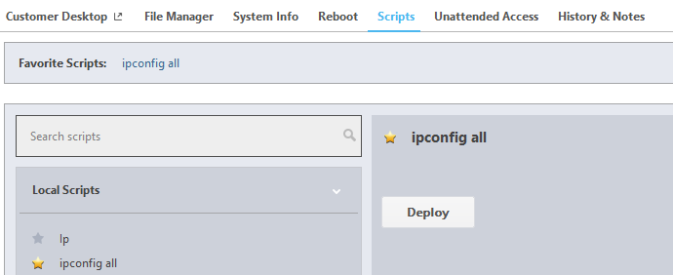

1. To run the script agent should **select** the **script** from the **Local scripts** then click **deploy**

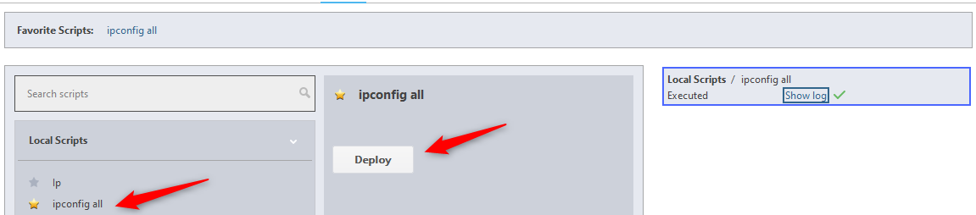

1. To view the **Output** **data** from the **Script** click on **Show log** then **copy to clipboard.**

